Echo cancellation

By ZhengChen

Table of Contents
1.1Initialization Parameters 6
1.2Pre-process 7
1.3Foreground filter output 8
1.4Proportional rate update 9
1.5Background filter update 9
1.6Background filter output 10
1.7Update foreground filter or reset background filter 10
1.8AEC output 11
1.9Reset Parameters 12
1.10Adaptive filter Covergence decision 12
1.11Learning Rate calculation 13
1.12Residual Echo Estimation 15

Change Log
Version | Description | Author | Date
0 | Initial version | Z.C | 17／7／11

Figure 1: Echo cancellation flowchart

Figure 2: Two-path algorithm

Definitions

N: frame size
M:delay blocks
Sff: foreground filter error variance
Sbb: background filter error variance
Sxx: far-end speech variance
Sdd: microphone signal variance
Davg1, Davg2, Dvar1, Dvar2 : parameters for update foreground filter/ reset background filter

Initialization Parameters
- Pre-process:

- Foreground filter output

- Proportional rate update

Ratio of 10 between adaption rate of the first and last block.

- Background filter upadte:

- Backgrounf filter output

- Update foreground filter or reset background filter

- AEC output

- Adaptive filter Convergence decision

- Learning Rate

Pre-process
- Microphone signal is applied with DC notch filter and pre-emphasis filter. Far-end speech is only applied with pre-emphasis filter.

- DC notch filter: A 2-st order IIR filter with configured coefficients, dicided by sampling rate. For typical sampling rate 8Ksym/s, the related coefficients are:
Numerator: [1 -2 1]. Denominator:[1 -1.62 0.7353]. Gain: 0.9

The DC notch filter process is as follows:

The filter frequency domain response is as follows:

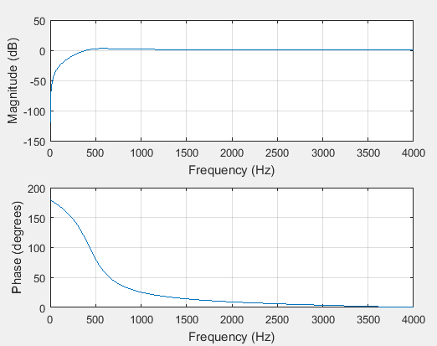
- Pre-emphasis filter: A FIR filter with coefficients: [1 -0.9].

For microphone signal:

For far-end speech:

The frequency domain response is as follows:
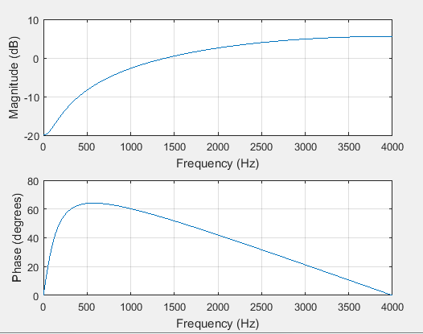

Foreground filter output
- Use MDF algorithm to calculate the estimated echo for foreground, then get error and related variance.

- Sff is used to decide if to update the foreground filter or reset the background filter.

Proportional rate update
- If the filter has convergenced, i.e . Use the initial proportional rate.

- If the adaptive has convergenced, i.e . The update process is as follows:

Background filter update
- The cofficients of background filter can be updated by MDF or AUMDF algorithm.

- For AUMDF algorithm, the final step is only applied for m=0 or other case.

Background filter output
- Sbb and Dbf is used to decide if update the foreground filter or reset background filter.

Update foreground filter or reset background filter

  - Parameters should be calculated every frame for the decision are as follows:

- The conditions to decide if to update foreground filter by background filter are any one of three as follows. Recommended foreUpdateVar1 is 0.5, foreUpdateVar2 is 0.25.

If satisfied, then

The smooth window is hanning window

- If the foreground filter update condition are all not satisfied, decide if to reset the background filter by foreground filter. Recommended backResetVar is 4.0.

if satisfied, then

AEC output
Generally, get the output by applying the filter foreground error with de-emphasis filter.

Reset Parameters
- The pesudocode for the reset logic is as follows:
if (!(Sxx>0&&Syy>0&&See>0)||!(Sxx<N*2e9&&Syy<N*2e9&&Sff<N*2e9))
then [screwedUpCnt = screwedUpCnt+50]
elseif (Sff>Sdd+N*5000)
then [screwedUpCnt = scrwedUpCnt+1]
else
then [screwedUpCnt = 0]
end

if (screwedUpCnt > 50)
then [screwedUpCnt = 0; reset]
end

- The reset parameters are as follows:

Adaptive filter Covergence decision
The adaptive filter has covergenced once all of the three conditions satisfied:

if satisfied:

Learning Rate calculation

Compute filtered spectra and (cross-)correlations:

The (cross-)correlation recursively result are:

Leakage estimation is:

Learning Rate estimation is:

If adptive filter has covergenced. i.e

If adaptive filter hasn't covergenced. i.e

Residual Echo Estimation
If adptive filter has covergenced. i.e

If adaptive filter hasn't covergenced. i.e

